

Simulation Project 2

EML 6351

by

Aahlad Vanam

13681791

3.

(a)Dynamic model:

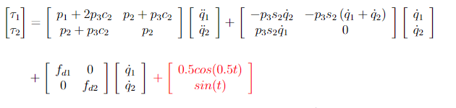

This is in the form of  = m(q)q̈ +Vm (q,q̇)q̇+Fdq̇ -----------------------(1)

d = 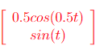

*(b)Simulation:*

***1. Rise Controller:***

*Gains Used:*

*K =5*

*a=1200*

*gamma = 10*

*alpha2 = 0.002*

*beta1 = 3.6*





*Given controller doesn’t stay in the required bounds which can be fine tuned by adjusting the gains*

***2. Composite Adaptive Controller plus Rise Controller***

*Gains used:*

K = 10

a = 1.6

gamma =

0.9000 0 0 0 0

0 1.0000 0 0 0

0 0 2.0000 0 0

0 0 0 3.0000 0

0 0 0 0 4.0000

beta = 0.99

alpha2 = 0.01

K2 = 10







1. **Composite Adaptive Controller**

Gains used:

K = 10, a= 5, gamma = 6, beta = 2



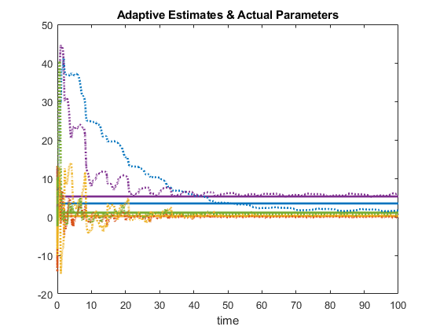



(c ) Discussion section:

1. Control gains had more effect on tracking errors than adaptation gains for the first controller. For the second controller and third controller, both played equal role in altering the tracking error.

2.Composite adaptive controller with additional RISE component has the best tracking performance among the given controllers.

3. The best adaptation performance is seen for the Composite adaptive controller with additional RISE component but the Composite adaptive controller doesn’t differ a lot from the former one.